**File system hierarchy overview**

**--------------------------------------------**

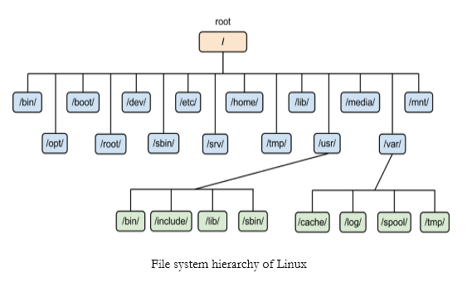

**/** : The file system root directory, from where the whole tree starts.

**/root**: It is the Admin or root user home directory

**/Home**: All normal user home directory.

**/boot**: Contains static files for the boot loader. This directory holds only the files which are needed during the boot process.

**/bin** : This directory contains executable programs, which help to execute commands by all users.

**/sbin**: This directory contains executable programs, which help to execute commands only by superuser or Admin user by default.

**/dev**: It contains Special or device files, which refer to physical devices such as Hard Drive.

**/etc**: Contains configuration files that are local to the machine.

**/lib**: This directory should hold those shared libraries that are necessary to boot the system.

**/media**: This directory contains mount points for removable media such as CDs and DVDs or USB sticks.

**/mnt** : This directory is a mount point for a temporarily mounted file system.

**/opt** : This directory should contain add-on packages that contain static files.

**/proc** : It provides information about running processes and the kernel.

**/run**: This directory contains information that describes the system since it was booted.

**/srv** : This directory contains site-specific data that is served by this system.

**/sys** : This is a mount point for the sysfs file system, which provides information about the kernel like /proc.

**/tmp** : This directory contains temporary files which may be deleted with no notice, such as by a regular job or at system boot-up. And the life span of this contains is 10 days.

**/usr** : This directory is usually mounted from a separate partition. It should hold only shareable, read-only data.

**/var** : This directory contains files that may change in size, such as spool and log files.

**/var/tmp** : Like /tmp, this directory holds temporary files stored for an unspecified duration. The life span for these contains is 30 days.